SPRA Member Workshops Tues 9th Oct 2018
Meeting Rooms 19 & 20, NEC Birmingham. Next to Halls 9 & 10

UK Construction Week Build Show is in Halls 9, 10, 11 & 12
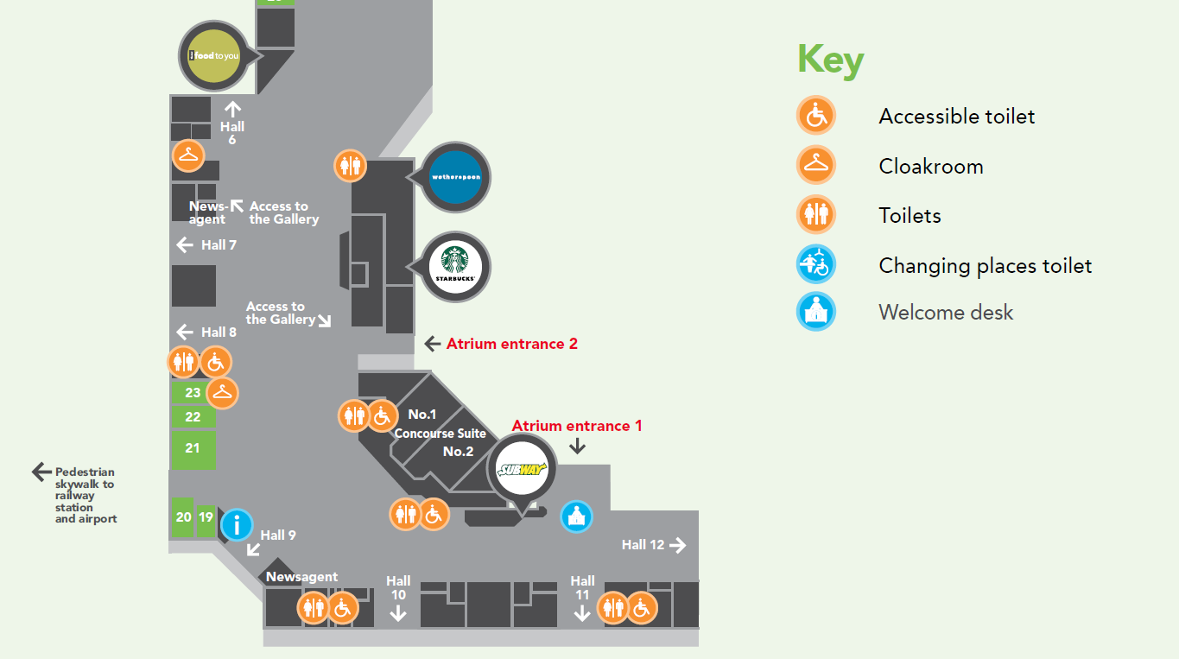
UKCW Halls 9 - 12
SPRA Workshops Rooms 19 & 20

Don’t forget to book your free tickets online to UKCW before the 9th October !:
https://ukconstructionweek18-visitor.reg.buzz/?affiliate=f9110c1e0718a654abb81da97a2a1408d4ed143171762753007f22f60413d5b3

GETTING TO THE NEC
The National Exhibition Centre is an exhibition centre located in Birmingham, England. Near junction 6 of the M42 motorway, and is adjacent to Birmingham Airport and Birmingham International railway station.

Questions? membership@spra.co.uk or Cathie.clarke@spra.co.uk
On the day: 07590 808060

